102商用木材 01
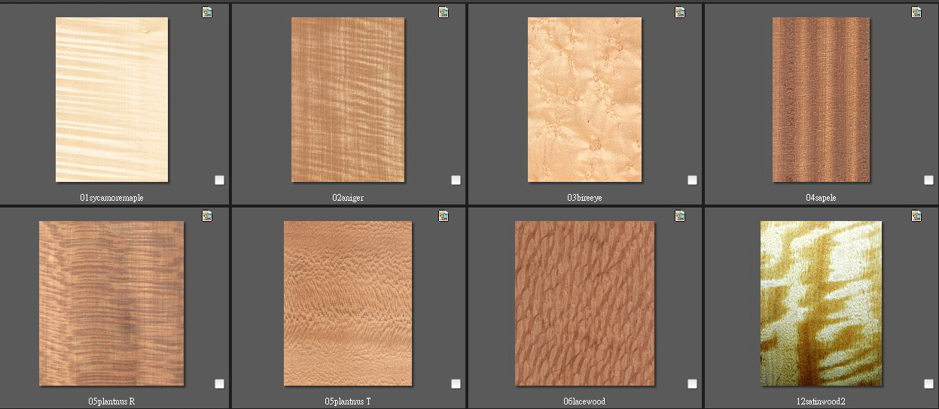

1 | 西卡摩 Sycamore maple | 5 | 帕迪那Platanus (徑切)
2 | 安妮格Aniegre | 6 | 帕迪那Platanus (弦切)
3 | 鳥眼楓木Bird's eye maple | 7 | 蕾絲木Lacewood
4 | 沙比力Sapele | 8 | 緞木Satin wood

西卡摩
1. http://delta-intkey.com/wood/en/www/aceac-ma.htm
2. http://www.cifap.utad.pt/acer_pseudoplatanus.htm
3. http://www.woodshopnews.com/news/wood-markets/498635-english-sycamore-sought-for-its-figure

安妮格
1. http://database.prota.org/dbtw-wpd/exec/dbtwpub.dll?AC=QBE_QUERY&BU=http://database.prota.org/search.htm&TN=PROTAB~1&QB0=AND&QF0=Species+Code&QI0=Pouteria+alnifolia&RF=Webdisplay
2. http://database.prota.org/PROTAhtml/Pouteria%20altissima_En.htm
3. http://www.biologie.uni-hamburg.de/b-online/wood/english/sapan-an.htm

鳥眼楓木
1. http://www.wood-database.com/lumber-identification/hardwoods/hard-maple/
2. http://en.wikipedia.org/wiki/Bird's_eye_figure

沙比力
1. http://www.flooringhardwood.com/html/sapelli.html
2. http://140.127.4.206:82/project/susan/wood-illustration/africa/a08.htm

帕迪納
1. http://delta-intkey.com/wood/en/www/plapl-sy.htm
2. http://www.hobbithouseinc.com/personal/woodpics/plane,%20european.htm
3. http://www.hobbithouseinc.com/personal/woodpics/_discussion_sycamore.htm
4. http://rosenstengelfurniture.com/?page_id=54

緞木
1. http://www.wood-database.com/lumber-identification/hardwoods/east-indian-satinwood/

